Anatomy of Forward Bends

- Label the curves and sections of the spine below:
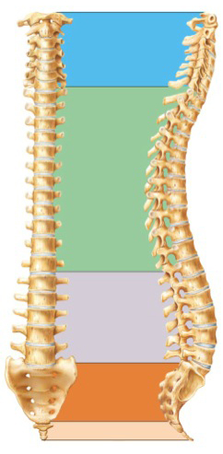

- During Uttanasana, with microbend in knee, start the forward bend with only hip flexion. How far can you actually go? If hamstrings feel tight, allow the knees to bend as you complete the pose with relaxed spinal flexion. Describe what factors into range of motion that can be a limitation in the hip flexion. Hint—which muscles can be too tight?

- What is spinal flexion? How is it done in a healthy versus unhealthy way? Do standing forward bends or seated forward bends load the spine more? Why? Describe in your group the potential to injure spine can happen in forward bends.

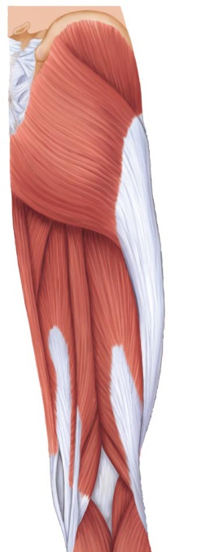
Draw arrows to the hamstring muscles. Reference pg 80 of training manual or powerpoint. Bonus—label the hamstring muscles!

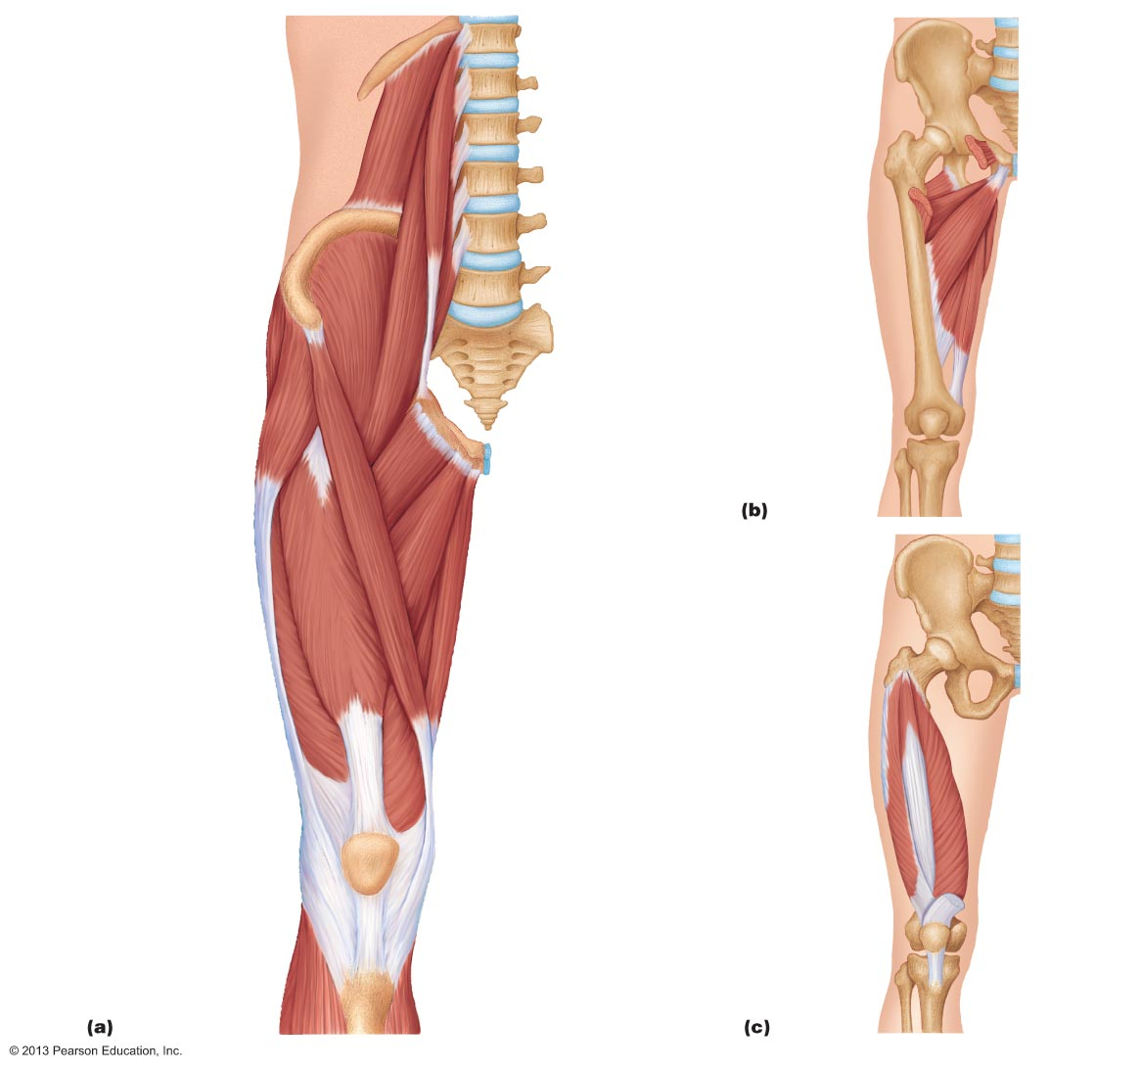
Examine the anterior thigh muscles to the left. Draw arrows to all quadricep muscles found in picture. Bonus—name the quadricep muscles!

Need to knows:
- What is the difference between hip flexion and spinal flexion?
- Anterior tilt and posterior tilt of the pelvis.
- What are the regions of the spine?
- Be familiar with the general location of the hamstring and quadricep muscles.

Associated Reading:
a. Manual: pgs 80, 86, 108-110
b. Key Muscles: pgs 19-21, 96-100, 103-109, 128-129

Bonus—Name the quadricep and hamstring muscles

