Anatomy of Inversions: Shoulder and Neck Anatomy
1. Label the muscles found on the following images. Using your available resources, list the actions of each muscle.
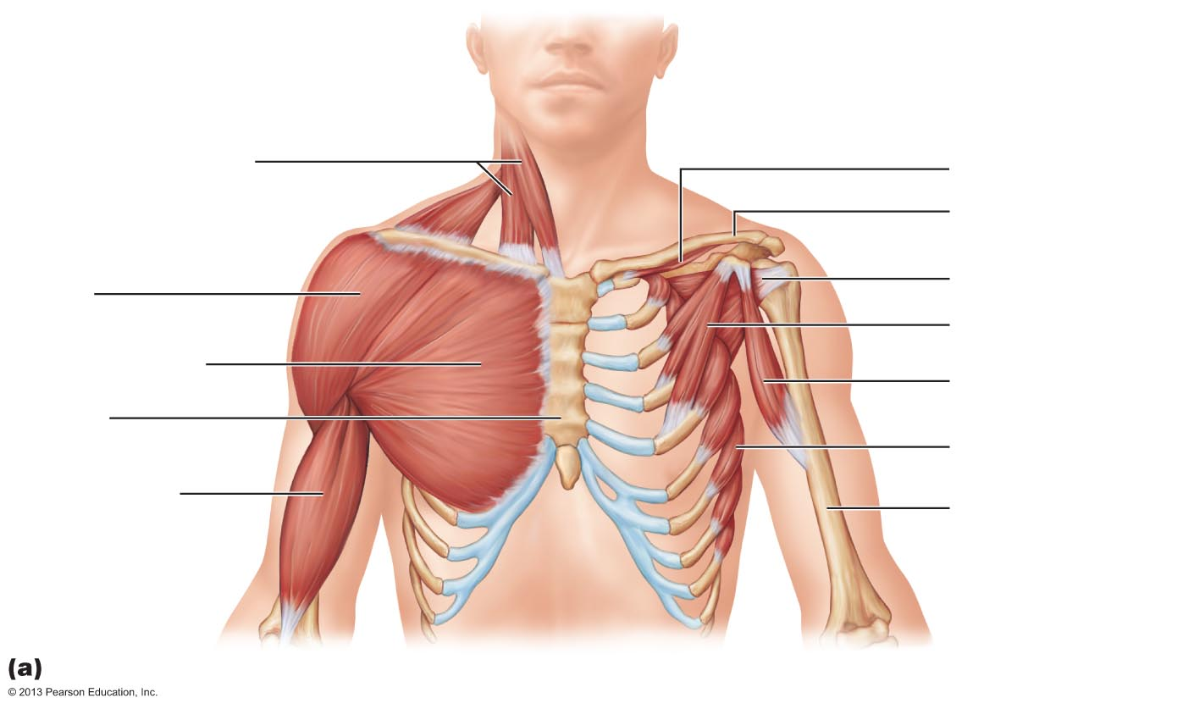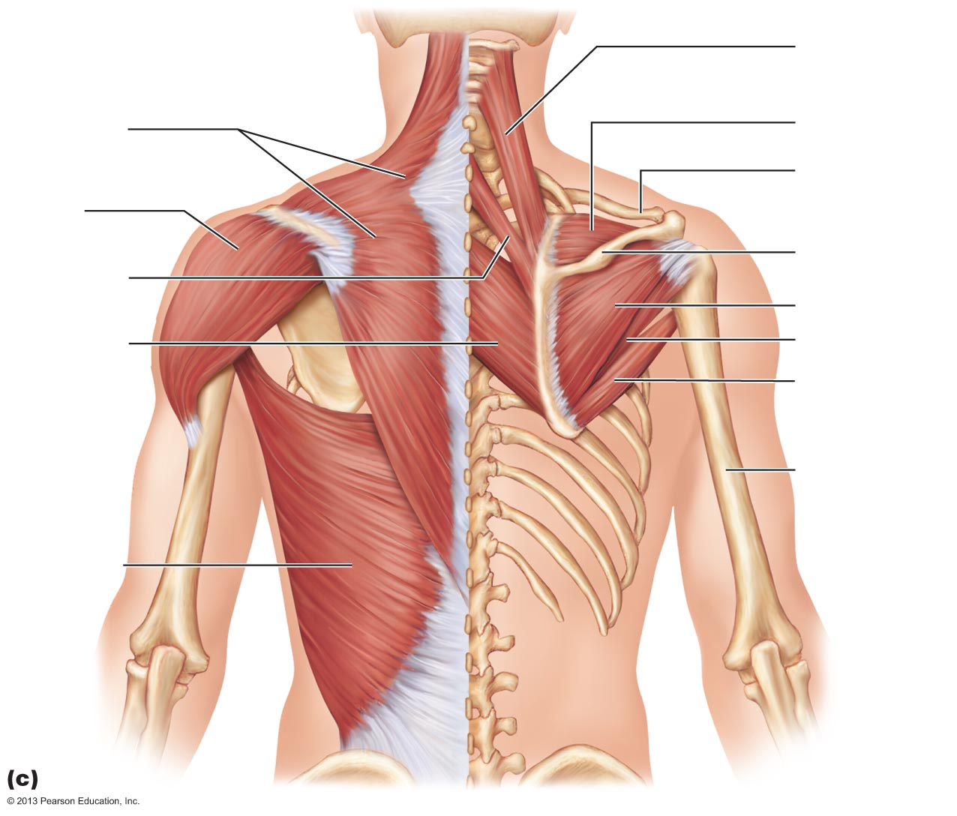
2. As we have discussed, proper muscle activation improves joint stability. In adho mukha svanasana, lifting upward through the heart and wrapping the shoulder blades around the torso stabilizes and protects the shoulder joint. What movements of the scapula and shoulder are occurring here? List any key muscles you can identify as being activated.
______________________________________________________________________________________________________________________________________________________________________________________________________________________________________________________________________________________________________________________________________________________________________________________________________________________________________________________________________________________________________________________________________________________________________________________________________________________________________________________________________________________________________________________________________________________________________________________________________________________________________________________________________________________________________________________________________________
3. In sarvangasana, discuss the alignment principles utilized to protect the neck from excessive cervical flexion including use of props, shoulder activation, and core activation.
___________________________________________________________________________________________________________________________________________________________________________________________________________________________________________________________________________________________________________________________________________________________________________________________________________________________________________________________________________________________________________________________________________________________________________________________________________________________________________________________________________________________________________________________________________________________________________________________________________________________________________________
4. In sirsasana, discuss the alignment principles utilized to protect the neck from excessive cervical flexion including use of props, shoulder activation, and core activation.
_____________________________________________________________________________________________________________________________________________________________________________________________________________________________________________________________________________________________________________________________________________________________________________________________________________________________________________________________________________________________________________________________________________________________________________________________________________________________________________________________________________________________________________________________________________________________________________________________
Need to knows:
- Upper body muscles: trapezius, latissimus dorsi, deltoid (posterior), rhomboids, serratus anterior, pectoralis major, pectoralis minor, biceps brachii, triceps brachii, teres major, sternocleidomastoid, and the rotator cuff group—supraspinatus, subscapularis, infraspinatus, teres minor.
- How to utilize proper biomechanics to support inverted weight!

Recommended Reading:
Inversions, shoulder, and neck anatomy
- Manual pgs. 186-188, 89-90
- KM pgs. 174-184

